Lighten
your
workload
Would you like to eliminate paper transcripts from your practice and even reduce how often you carry your laptop with you? If so, go mobile with
RB Transcript Packages

RB Transcript Packages are:
- Designed to work natively on mobile devices like iPhones and iPads.
- Better than PDF or other transcript formats for viewing on mobile devices because they provide maximum legibility on these smaller screens.
- Easy to learn and use because they work like other mobile apps.
- Convenient because they eliminate the need to always bring along your laptop if you want to work away from your desk.

With RB Transcript Packages,
you can:
- Work with your transcripts on your smartphone.
- Search for specific text or by page number.
- Highlight specific lines.
- Make detailed notes on specific lines and attached files.
- Search through highlights and notes in transcripts.
- Export a copy of the transcript in a variety of formats, including condensed, highlights only, or notes.
- View or download attached exhibits, videos, and other files, such as the original ASCII.
- Work with the same transcript on other devices, such as a laptop, desktop computer or iPad.
Get more done, faster and easier than before, with RB Transcript Packages
from OMTI,
developers of
ReporterBase legal support software &
RB Connect online offices with case repositories

Same transcript, different devices
Whether you access RB Transcript Packages on a smartphone, tablet, laptop, or desktop computer, you get the same features, but they are customized to work better on each device.
The mobile version works like other smartphone apps. You tap the screen to make a selection, and you drag to scroll through long text or option lists.
The other version is designed for the larger screens of your desktop and laptop. More information is visible at the top level. So you can see the list of attached exhibits, video, and other files on the same screen with your transcript. And features like the export options open as panels next to the main display.
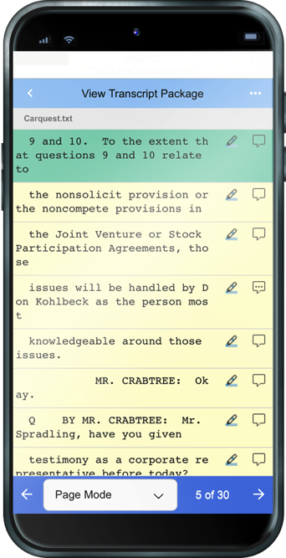
How RB Transcript Packages work on your smartphone
When you open a Transcript Package on your smartphone, it looks similar to a printed transcript. The text appears with the same line and page breaks as in the original transcript.
- You can search for a particular word or phrase, and page through each instance in the transcript. You will also see how often your search item appears in the transcript.
- Jump to a specific page by entering its number in the Go To popup.
- Click a hyperlink in the transcript to view the related exhibit.
- To highlight a line, tap the highlighter icon at the right side of the line. In the popup that appears, select which color to highlight the line. You can also add or remove highlight colors, so you can organize highlighted lines by categories.
- Use Highlight Mode to page through your highlighted lines.
- To add a note, tap the word balloon icon at the right side of the line, then enter your text. When done, the word balloon icon changes to indicate a note is attached to that line. Tap the icon to view and edit your note.
- Use Notes Mode to page through the lines in your transcript that have notes attached.
- Export a copy of the entire transcript in AMICUS format, as a PDF transcript, a condensed transcript, a word index, or a word list. You can fully customize the PDFs to your specs, choose whether to export a 2-up or 4-up condensed transcript, and include a word count in your word list.
- You can also export copies of your highlights and notes. If exporting highlights, you can choose to export one category of highlighted text or all categories. The exported file lists the highlighted text and includes the page, line, and highlight label for each line listed.
- View or download related exhibits, video, or other files attached to the transcript.
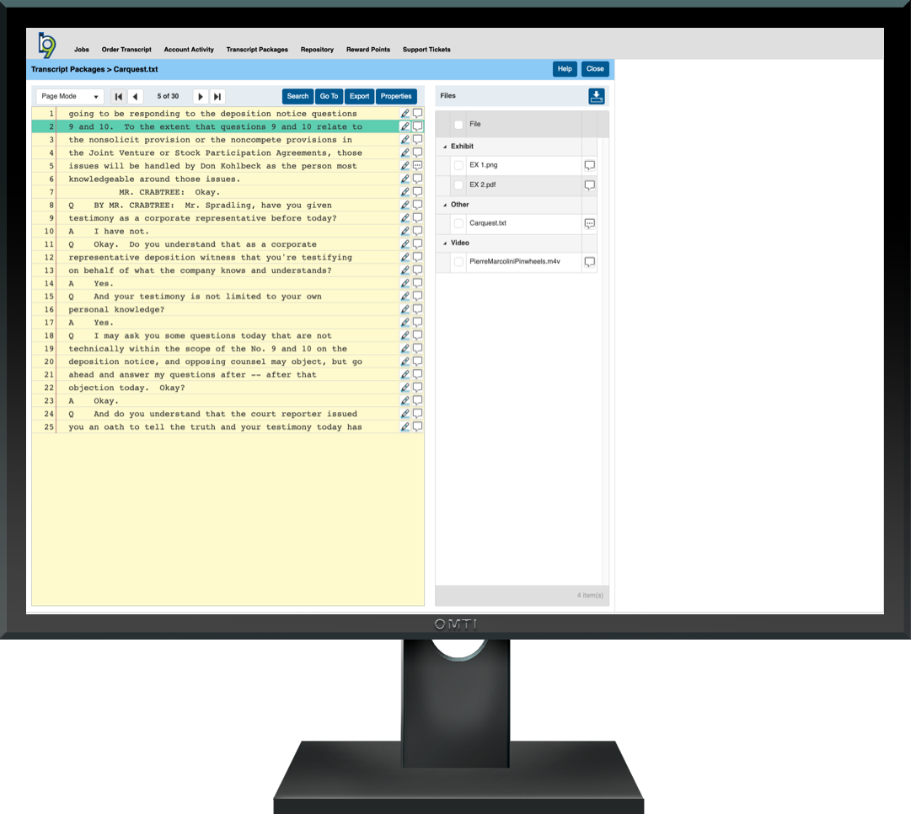
How RB Transcript Packages work in a browser
You get the same features, and the transcript looks and works similar to its smartphone version, but you can see more of the transcript and its features on the main screen.

More ways to get things done easier
RB Transcript Packages are one of our services available through RB Connect online offices. In addition to transcript packages, you can use our online offices to:
- Check your depo schedule, and see at a glance which jobs have been canceled.
- Request reporters and other services.
- View any scheduled job’s details, including driving directions.
- Order transcripts.
- View and download job and case files. You can view streaming video online, so you don’t have to wait for a large file download first.
- Look up outstanding and paid invoices, and view invoice details. Even pay invoices online.

